Q. Demonstrate the static Routing in Packet Tracer.
Aim : To write a code to demonstrate static routing in packet tracer. Steps:
- In packet tracer take 2 PCs and 2 Routers.
- Connect Router0 with PC0 via fastethernet0/0 using cross-copper cord and Router1 with PC1 via fasethernet0/0 using cross-copper cord.
- Connect both router via fastethernet0/1 using cross-copper cord.
- Set the IP address and default gateway of both the PCs in ip configuration of both the PCs respectively.

Topology:
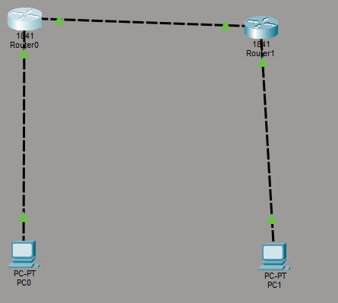
Code: Router0:
Router> enable
Router# configure terminal Router(config)# interface fastethernet0/0
Router(config-if)# ip address 10.0.0.1 255.0.0.0

Router(config-if)# no shutdown Router(config-if)# exit
Router(config)# interface fastethernet0/1 Router(config-if)# ip address 20.0.0.1 255.0.0.0 Router(config-if)# no shutdown
Router(config-if)# exit
Router(config)#ip route 40.0.0.0 255.0.0.0 20.0.0.2 Router(config)#exit
Router1:
Router> enable
Router# configure terminal Router(config)# interface fastethernet0/0
Router(config-if)# ip address 20.0.0.2 255.0.0.0 Router(config-if)# no shutdown
Router(config-if)# exit
Router(config)# interface fastethernet0/1 Router(config-if)# ip address 40.0.0.1 255.0.0.0 Router(config-if)# no shutdown
Router(config-if)# exit
Router(config)#ip route 10.0.0.0 255.0.0.0 20.0.0.1 Router(config)#exit

Verification: In Both PCs Command Prompt.

PC0:

PC1:

PC0:

C:\ipconfig C:\ping 10.0.0.1
C:\ping 10.0.0.2
C:\ping 20.0.0.1
C:\ping 20.0.0.2
C:\ping 40.0.0.1
C\:ping 40.0.0.2

C:\ipconfig C:ping 40.0.0.1
C:ping 20.0.0.2
C:ping 20.0.0.1
C:ping 10.0.0.1
C:ping 10.0.0.2

Output:

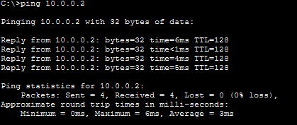

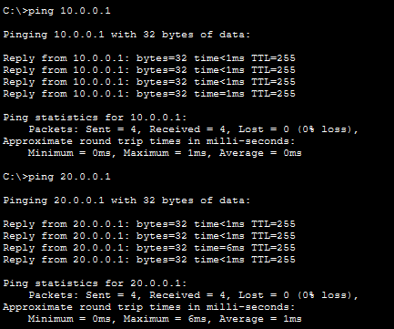
PC1:
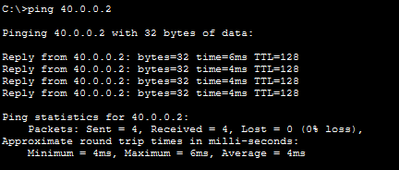
Conclusion:The above Topology has been executed successfully.

